PROJECT DOCUMENTATION
AUTO TICKET CLASSIFICATION
USING FLOW DESIGNER

Govt Arts College for women in Ramanathapuram- ALUAU15
Computer Science-3 year

Submitted By:

Team Leader : NANDHINI DEVI R
Members : 1.SIVASAKTHI R
2.SIVASANKARI P
3.SUBALAKSHIMI D
4.THARSHIKA B

Project Abstract

This project designs a no-code School IT support ticket classification system on the ServiceNow platform. Students create tickets by entering their caller details and a short description. A Flow Designer automation reads the short description, identifies configured keywords, and updates the ticket Category and Subcategory. The proposed rules cover Wi-Fi or network, projector, password or login, and slow or hanging computer issues. After classification, the flow sends a confirmation email to the caller. The project also covers a custom table, dependent choice fields, testing, and deployment using an Update Set.

1.Introduction

Manual categorization of school IT requests can be inconsistent and time-consuming. This project uses ServiceNow custom tables and Flow Designer to standardize the first stage of ticket handling without requiring the student to select technical classifications.

2. Problem Statement

Students may not know which IT support category or subcategory to choose. Manual classification can delay routing and lead to incorrect or incomplete ticket data. An automated rule-based process is needed to classify common incidents from short descriptions and notify the requester.

3. Objectives

- Create and select a Project Update Set in the Global application.
- Build an Incident WorkFlow custom table with auto-numbering and required fields.
- Configure Category, Subcategory and State choices, including dependent subcategories.
- Automatically classify newly created tickets using Flow Designer conditions.
- Send confirmation email to the ticket caller.
- Validate sample scenarios, access permissions and Update Set export.

4. Tools and Requirements

Component | Requirement
Platform | ServiceNow instance with permissions for tables, update sets and Flow Designer
Browser | Chrome, Edge or another supported web browser
Network | Stable internet connection
ServiceNow features | Local Update Sets, System Definition Tables, Form Designer, Flow Designer, Email logs
Implementation style | Rule-based, no-code classification; no machine-learning model is trained

5. System / Workflow Diagram
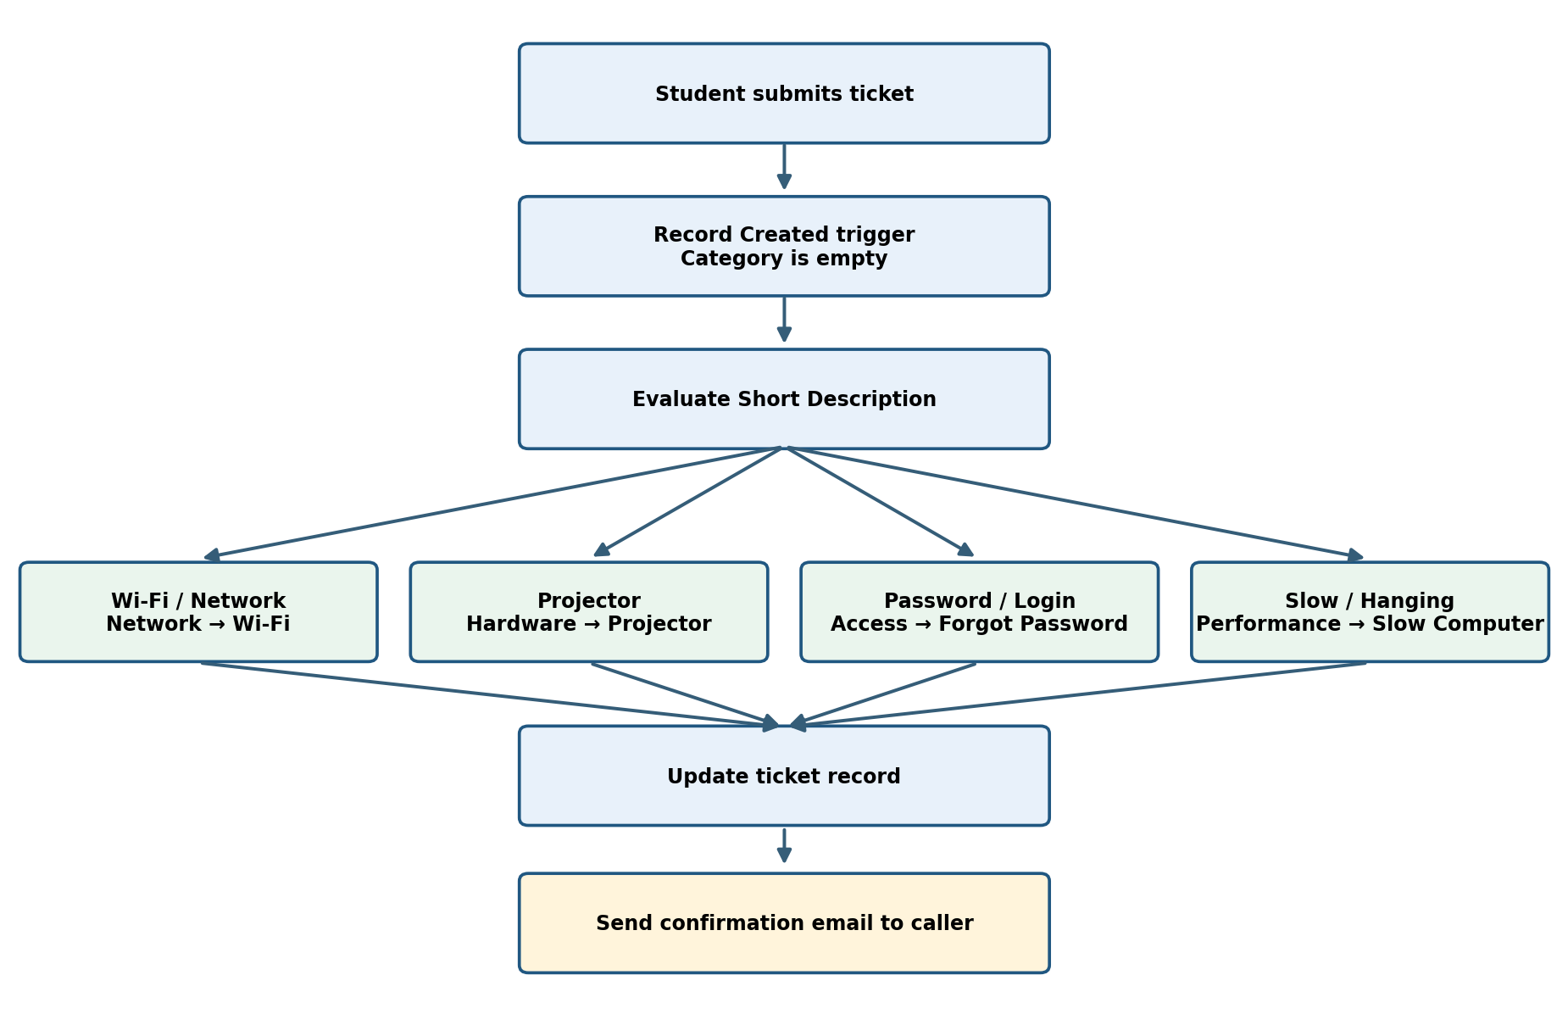

6. Project Implementation

Phase 1 — Create and Select the Update Set
- Navigate to All → System Update Sets → Local Update Sets.

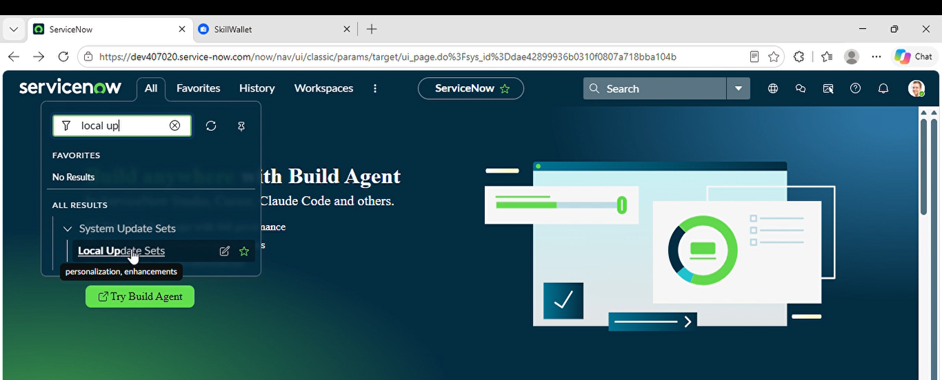

- Click New and enter Name: Project Update Set; State: In progress; Application: Global.

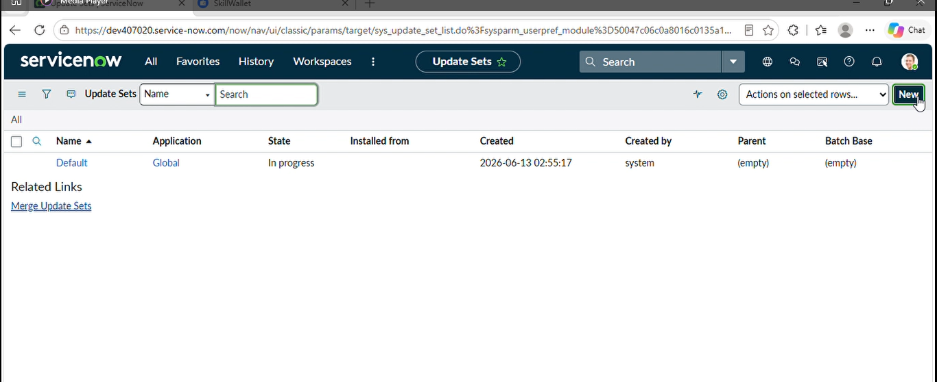

3.Save the form and select Make This My Current Set under Related Links.

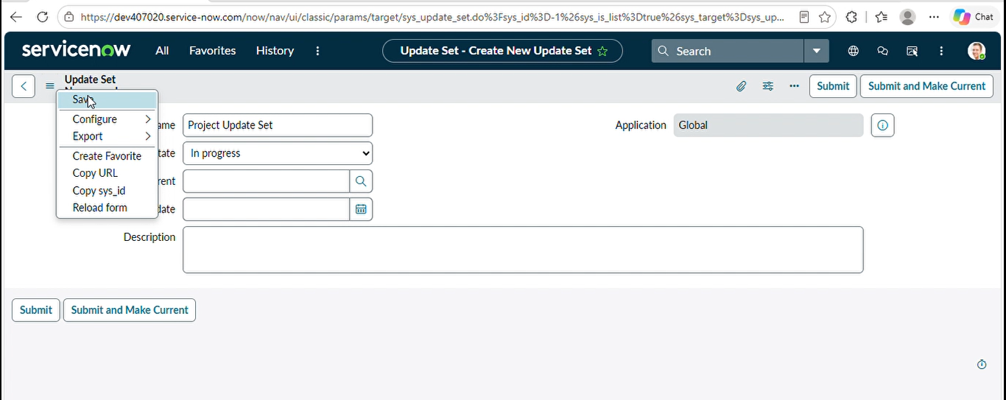

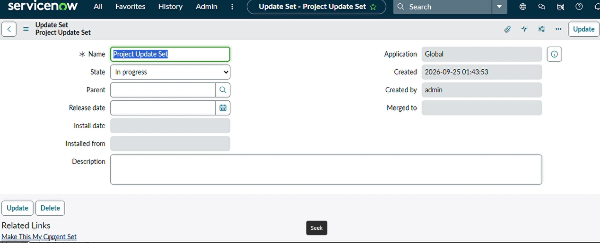

- Verify that Project Update Set appears as the current update set.

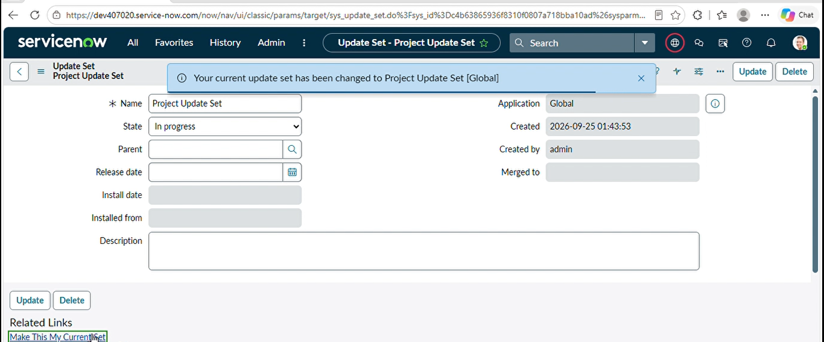

Phase 2 — Backend Development and Configuration

Activity 1: Create the Custom Ticket Table
- Open All → System Definition → Tables, then click New.

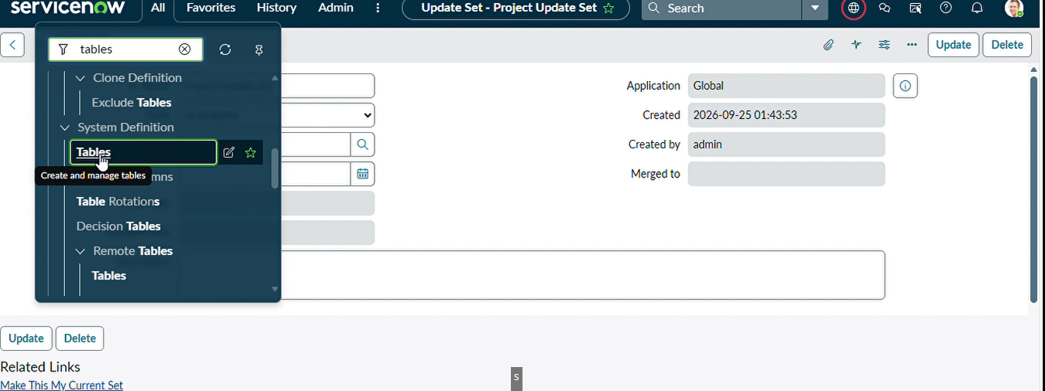

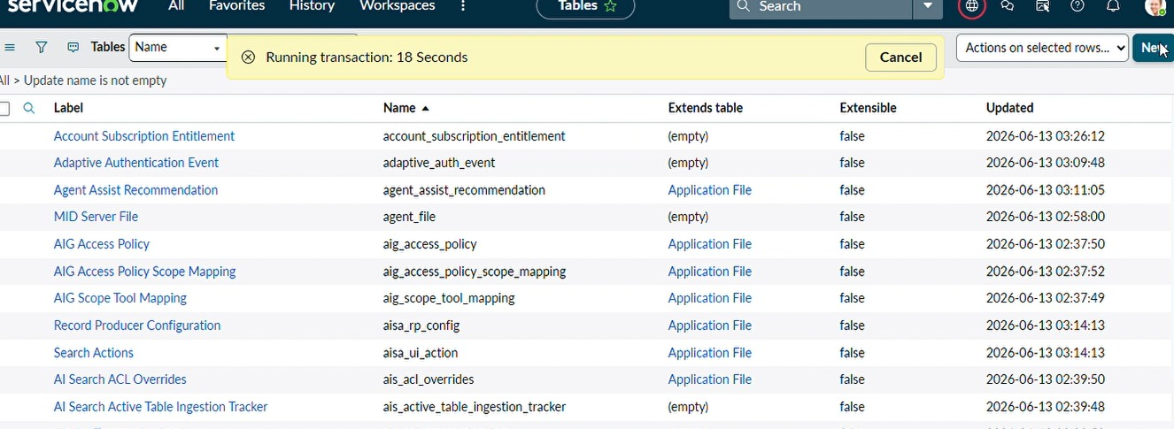

- Set Label to Incident WorkFlow and uncheck Create module.

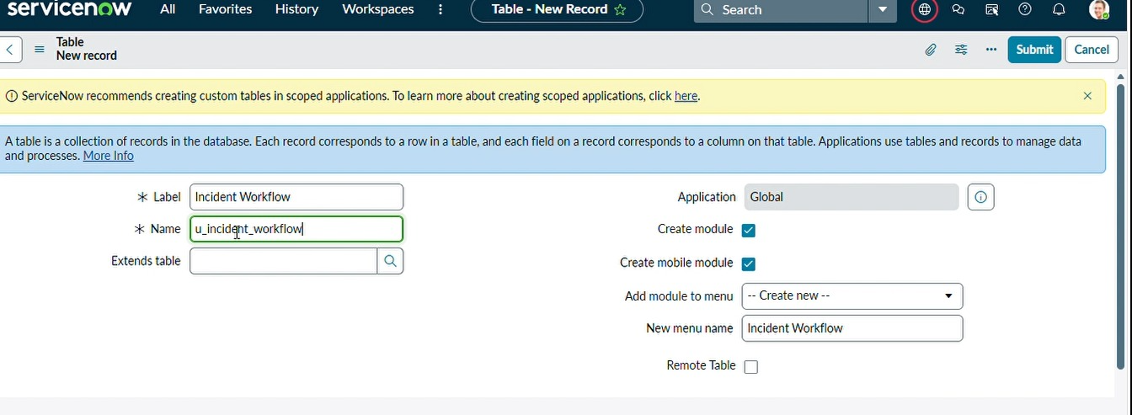

- Save the table, open Controls and enable Auto Number. Save again.

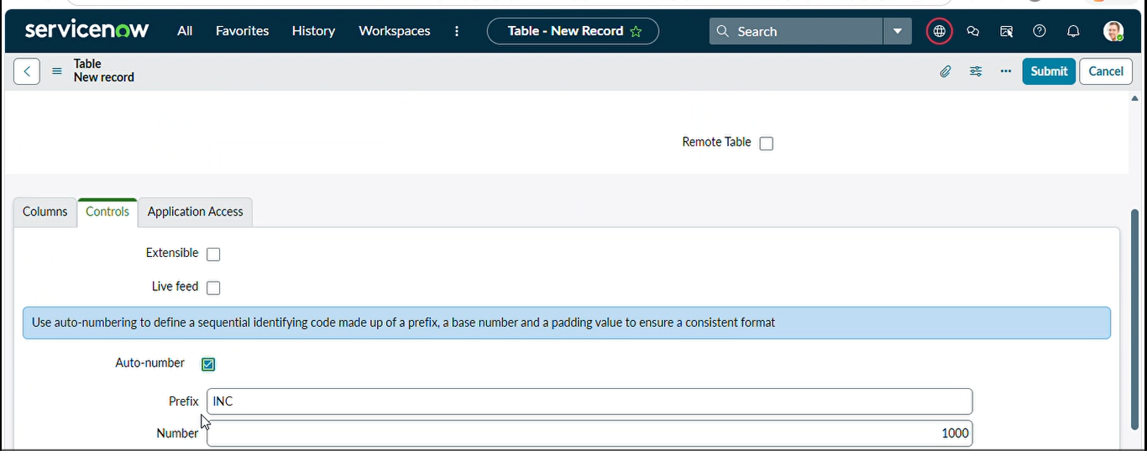

- Select Show Form under Related Links, open the form context menu, and choose Configure → Form Designer.

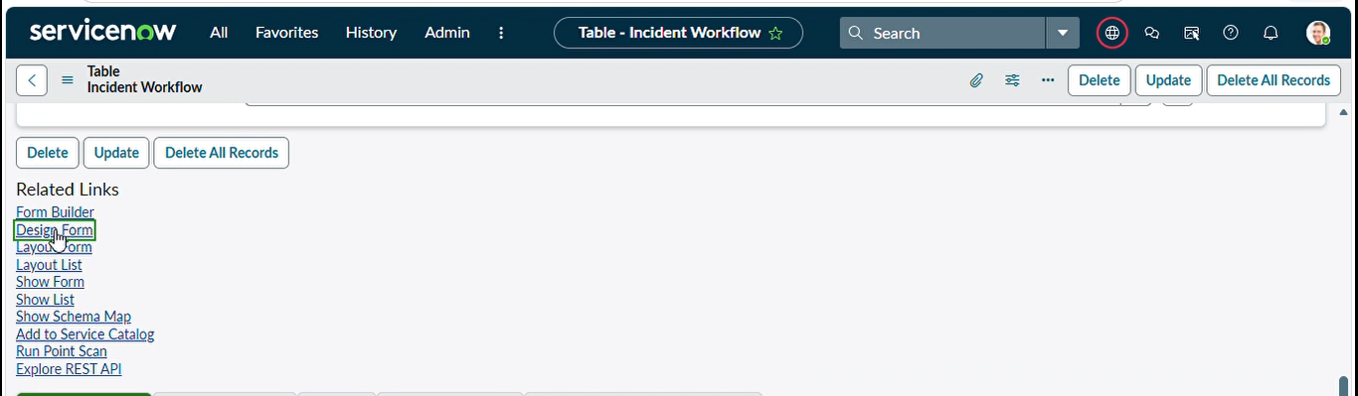

Activity 2: Create Fields and Configure Data Types
Field label | Type | Choices / reference
Number | Auto Number | Automatically generated
Caller | Reference | sys_user
Category | Choice | Network; Hardware; Access; Performance
Subcategory | Choice | Wi-Fi; Projector; Forgot Password; Slow Computer
Short Description | String | Student issue summary
Description | String | Additional issue details
State | Choice | New; In progress; On hold; Resolved; Closed
Assigned Group | Reference | sys_user_group
Assigned to | Reference | sys_user

Add the Category, Subcategory and State choice values in Form Designer or the choice configuration, save the form and reload to confirm that the fields display. The exact technical table name is generated by the instance; use the created table record rather than assuming its name.

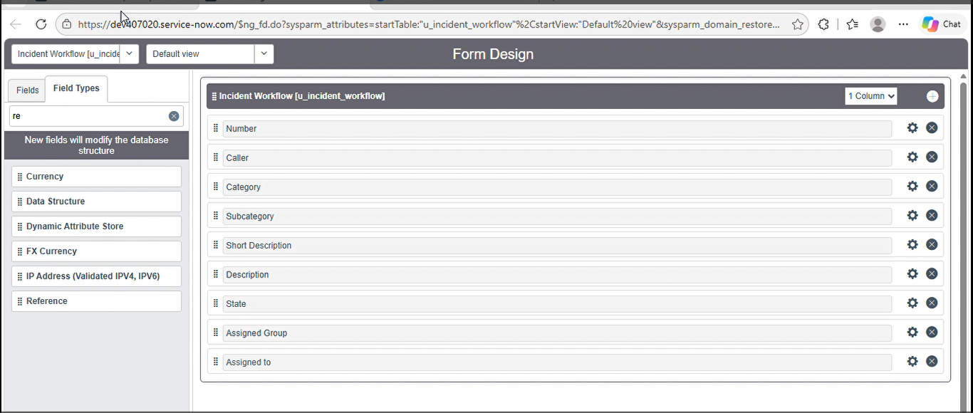

Activity 3: Configure Category–Subcategory Dependency
- On the ticket form, right-click Subcategory and select Configure Dictionary.

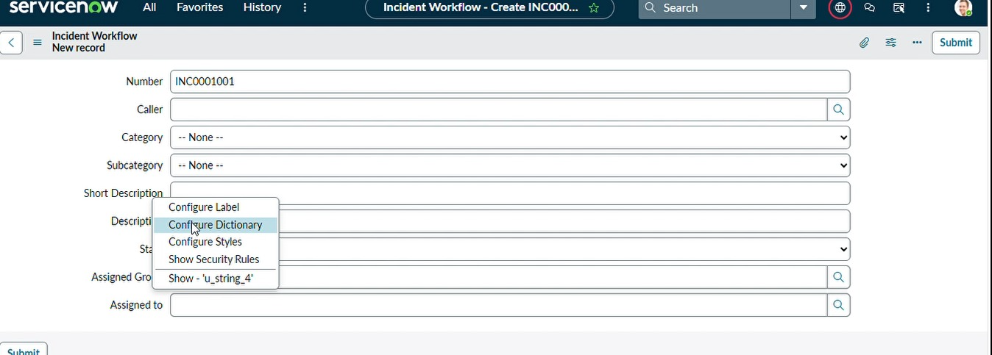

- Open Advanced view and enable Use dependent field.

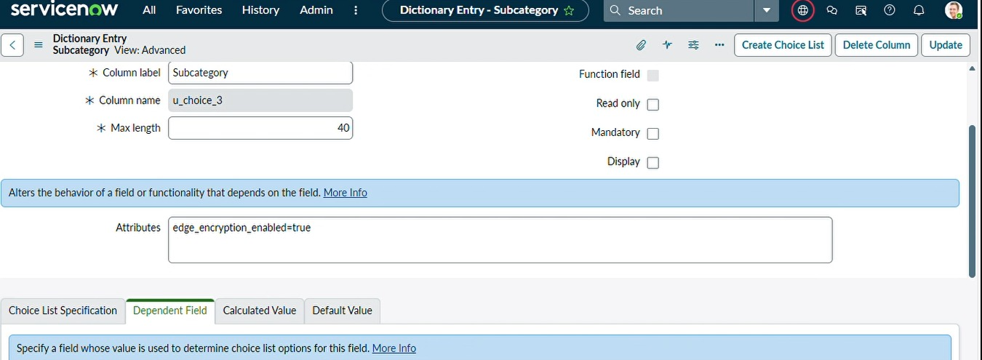

- Set Dependent on field to Category and save.

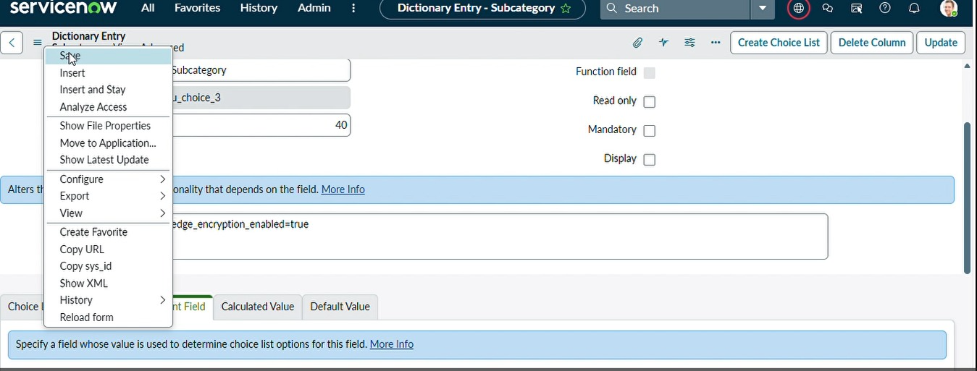

- For each Subcategory choice, set its dependent value to the matching Category choice backend value.
- Save and verify that changing Category filters the Subcategory options.
Category | Visible dependent subcategory
Network | Wi-Fi
Hardware | Projector
Access | Forgot Password
Performance | Slow Computer

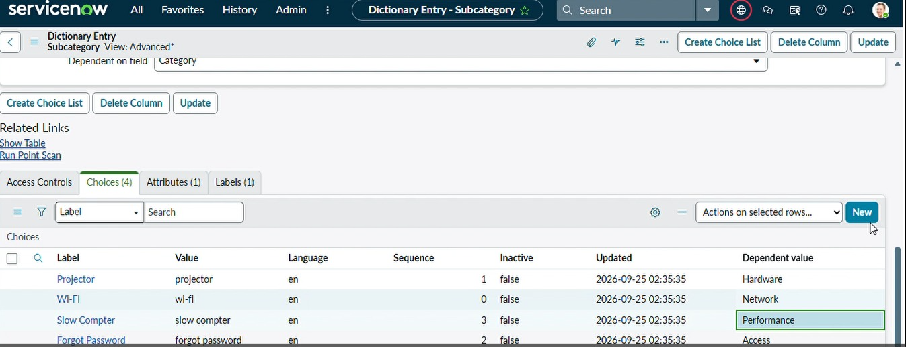

Phase 3 — Automation Using Flow Designer & Email Notification

Activity 1: Create the Flow
- Navigate to All → Process Automation → Flow Designer.

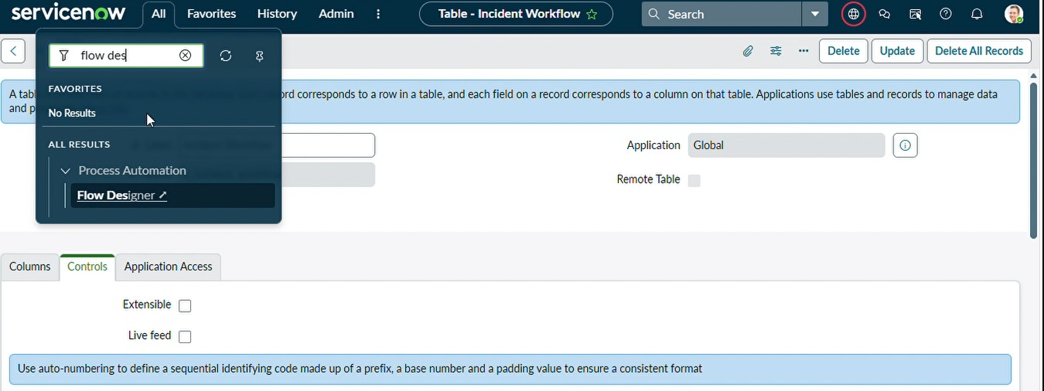

- Click New → Flow.

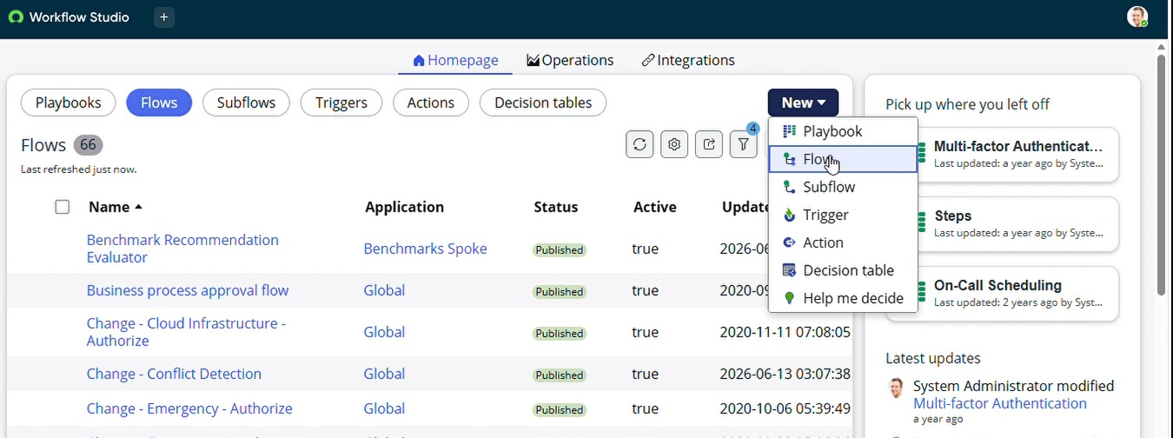

- Enter Name: Auto Classify School IT Tickets; Application: Global.

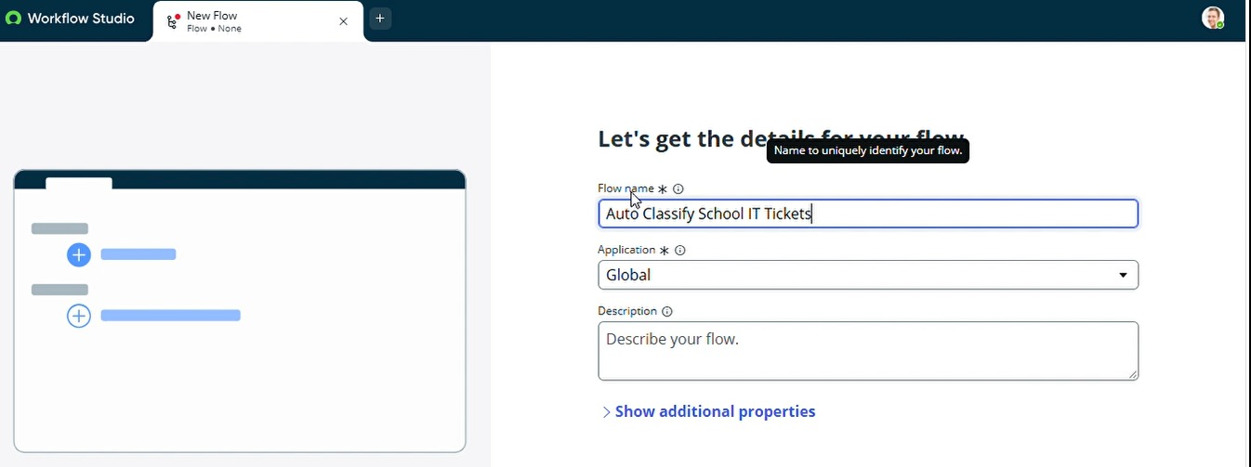

Activity 2: Configure the Trigger
- Choose Trigger: Record Created.
- Choose the custom Incident WorkFlow table.
- Set condition: Category is empty.
- Click Done and add Flow Logic.

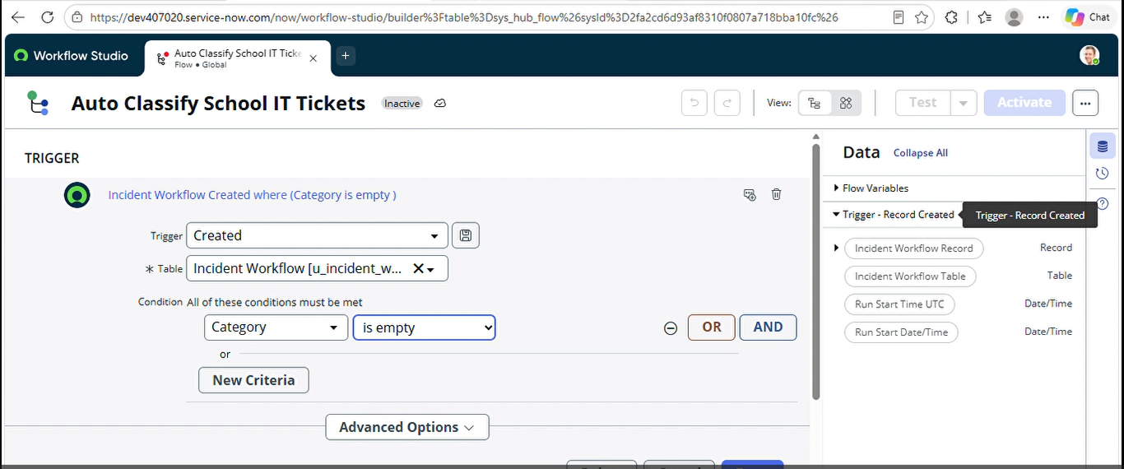

Activities 3–6: Configure Classification Rules
Use an If followed by Else If branches. Each matching branch uses Update Record on the record from the trigger. The intended keyword-to-field mapping is:
Branch | Short Description contains | Set Category | Set Subcategory
If — Wi-Fi | Wi-Fi OR Network | Network | Wi-Fi
Else If — Projector | Projector | Hardware | Projector
Else If — Password | Forgot password (also Password / Login if added) | Access | Forgot Password
Else If — Slow Computer | Slow Computer (also Slow / Hanging if added) | Performance | Slow Computer

Important implementation detail: the supplied milestone describes broader keywords (WiFi, Password/Login and Slow/Hanging), while the detailed activity steps use narrower phrases. Add the extra OR conditions if you want the broader descriptions to match. For Wi-Fi, account for both “WiFi” and “Wi-Fi” spellings where needed.
- For each branch, add the matching condition on Short Description.
- Add Update Record and select the triggering Incident WorkFlow record.
- Set Category and Subcategory to the values in the table.
- Save each branch and check the flow sequence.

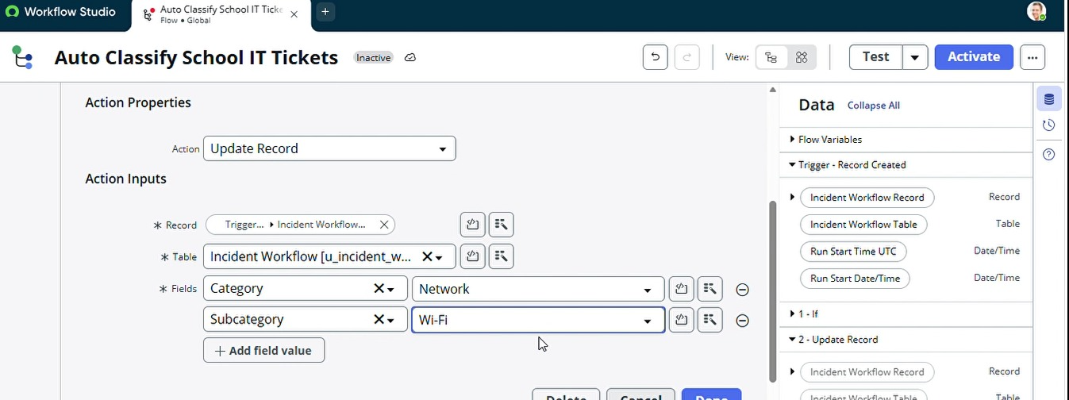

Activity 7: Configure Email Notification
- After the classification branches, add a Send Email action.
- Set To to Caller → Email using the available data pill.
- Set Subject to: Your Request for the issue has been submitted.
- Write a ticket confirmation message in the body.
- Save and Activate the flow.
Recommended email body: “Your IT support request has been received. Ticket number: [Number]. Category: [Category]. Subcategory: [Subcategory]. Our support team will review your request.” Replace the bracketed values with the appropriate data pills.
If email should only be sent after successful classification, place the Send Email action on the matching paths or add an explicit classification check before sending.

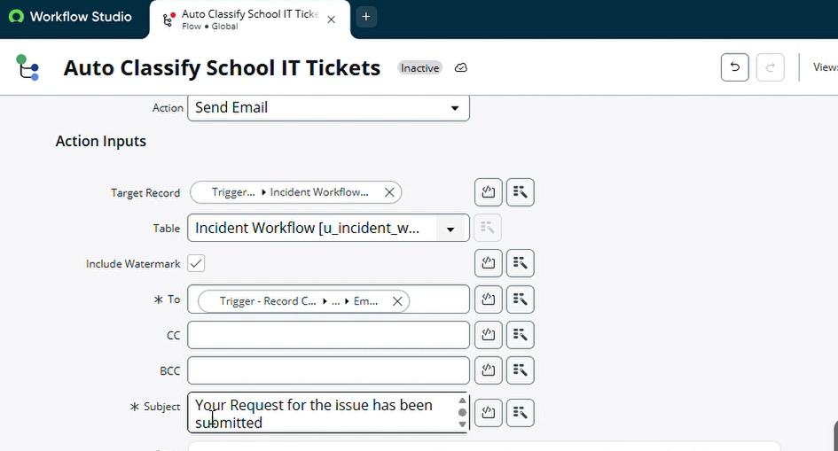7. Testing, Validation & Security
The following are planned acceptance tests based on the supplied instructions. Do not mark a test Pass until it has been run in the actual ServiceNow instance.
ID | Input / action | Expected result | Actual / status
TC-01 | Caller + “WiFi not working in library” | Network / Wi-Fi; confirmation email | [Fill after testing]
TC-02 | Caller + “Projector not turning on” | Hardware / Projector; confirmation email | [Fill after testing]
TC-03 | “Forgot password” | Access / Forgot Password | [Fill after testing]
TC-04 | “Slow Computer” | Performance / Slow Computer | [Fill after testing]
TC-05 | Change Category on form | Only matching Subcategory choices visible | [Fill after testing]
TC-06 | Create two tickets | Unique auto-generated ticket numbers | [Fill after testing]
TC-07 | Create ticket with unmatched description | No false classification; manual review | [Fill after testing]
TC-08 | User without edit permission attempts update | Access denied per configured ACLs | [Fill after testing]

Email Log Verification
- Open All → System Logs → Emails.
- Search for the configured subject.
- Open the matching email record and use Preview Email / Preview Mail if available.
- Confirm recipient, ticket details and email delivery status.

Data Validation and Security Checklist
- Confirm required fields are captured and ticket numbers are unique.
- Verify Category / Subcategory values and reference fields resolve correctly.
- Review table and field ACLs so only authorized users can view or modify ticket data.
- Check that email recipient is the caller and does not expose other users’ information.
- Verify that the flow does not overwrite a manually classified ticket when Category is already populated.

8. Deployment and Final Documentation
- Navigate to All → System Update Sets → Local Update Sets.
- Open Project Update Set and change State from In progress to Complete.
- Save and choose Export to XML under Related Links.
- Store the exported XML with the final report; transfer it to the target instance using the standard update set import/review process.
- Retest the imported configuration and verify dependencies, flow activation and email behavior.

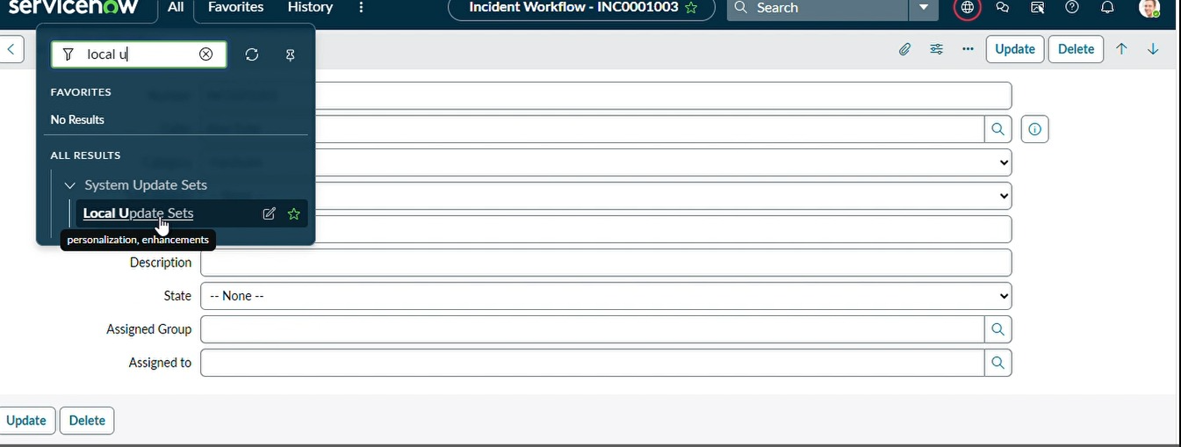

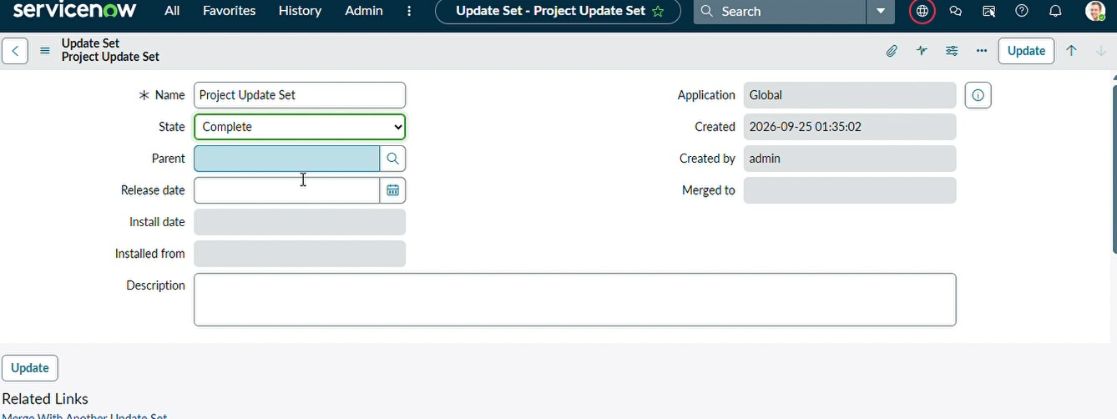

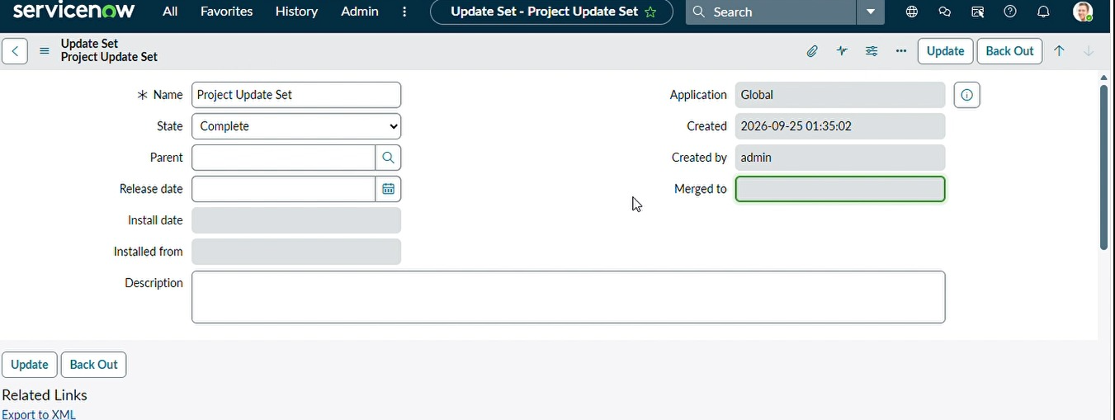

9. Known Limitations and Future Enhancements
- Keyword rules can miss spelling variants and complex descriptions; extend conditions and add an unmatched-ticket review path.
- Multiple keywords in one description follow the first matching If / Else If branch; document the precedence.
- Consider automatic assignment groups, SLAs, escalation notifications and reporting after the initial workflow is validated.
- Email delivery depends on the instance’s outbound email configuration and permissions.

10. Conclusion
The proposed ServiceNow solution combines a custom Incident WorkFlow table, dependent choice fields, Flow Designer keyword rules, and caller email notifications. Once configured and validated, it can reduce manual classification for common school IT issues. The project is packaged in a Project Update Set for controlled transfer and future enhancement.

